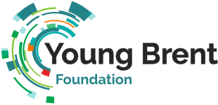

Training Needs
In preparation for our network meeting, please consider the following training areas:
- Effective Data Collection
- Effective Articulation of your Impact
- General Business Skills – business skills modules that fit into your project/programme needs, e.g., budgeting, technological literacy
- Youth Engagement/Networking - new ways of working with young people and bringing them onto your programmes/projects.
- Funding and Bid writing Applications
- Fundraising

Breakout room discussion:
In your breakout rooms please discuss the following questions:
- From the training areas listed, what is a priority for you?
- Are there any areas missing?
- Choose a couple of areas and as a group discuss having received training, how might you put your learning into practice? for example, following a data collection training session you create your own project/programme evaluation forms, as a means of capturing data on your delivery.

We look forward to seeing you all!

