Maxine Willetts
Young Brent Foundation | Barham Park Community Complex, 660 Harrow Road, HA0 2HB
Young brent Foundation
One Flow One Brent Board Members candidate pack
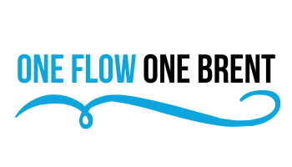
Welcome

Thank you for your interest in Young Brent Foundation

The purpose of this induction pack is to provide you with all the information and documents necessary to assist you succeeding in your role.

One Flow One Brent is a programme that aims to tackle the drivers of violence across Chalkhill, Stonebridge and Church End Estates. The programme is powered by a unique consortium of partners, bringing together the Young Brent Foundation, local young people and three of the country’s largest housing associations – Metropolitan Thames Valley Housing (MTVH), Hyde and Catalyst.

We know that violence knows no border, and it is not focused on an entire borough. Instead, it tends to be localised in neighbourhoods or even in small pockets of roads. Experience tells us that it is often local people who know what is best for improving the area they live and work in.

As someone joining a Project that launched in 2021, you will have the opportunity to shape One Flow One Brent, helping to bring its vision to life. Working with your Board colleagues and the One Flow One Brent project team, you will help shape our long-term strategy for reducing violence in our communities, then hold the executive team to account for delivery.

You will bring your experience and contacts to bear as an independent, critical, yet supportive friend to the staff team and an important ambassador for One Flow One Brent with external stakeholders. If you share our passion and commitment to create a society where all young people have equitable access to safe neighbourhoods, good quality youth provision and support when needed, then I look forward to hearing from you.
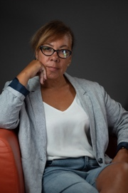
Maxine Willetts
Chief Operating Officer

About Young Brent Foundation

Developed in response to the ongoing challenges facing the children and young people's sector, young people's foundations bring together the public, private and voluntary sectors to effect positive change for young people.

Young Brent Foundation's aim is to create an evidence based, needs led community partnership model that unites a diverse voluntary youth sector, and creates a strong united voice, equipping members with the training, resources, and financial support they need to increase overall capacity and develop a more sustainable future to benefit young people. As enablers and facilitators, we work alongside members and deliver a wide range of capacity building focused activities.

About the programme
One Flow One Brent will deliver an innovative programme of intervention for the young people of these estates. The aim of this programme is to provide much needed opportunities for young people, to increase community participation and community safety, whilst keep young people at the heart of the decision-making process.

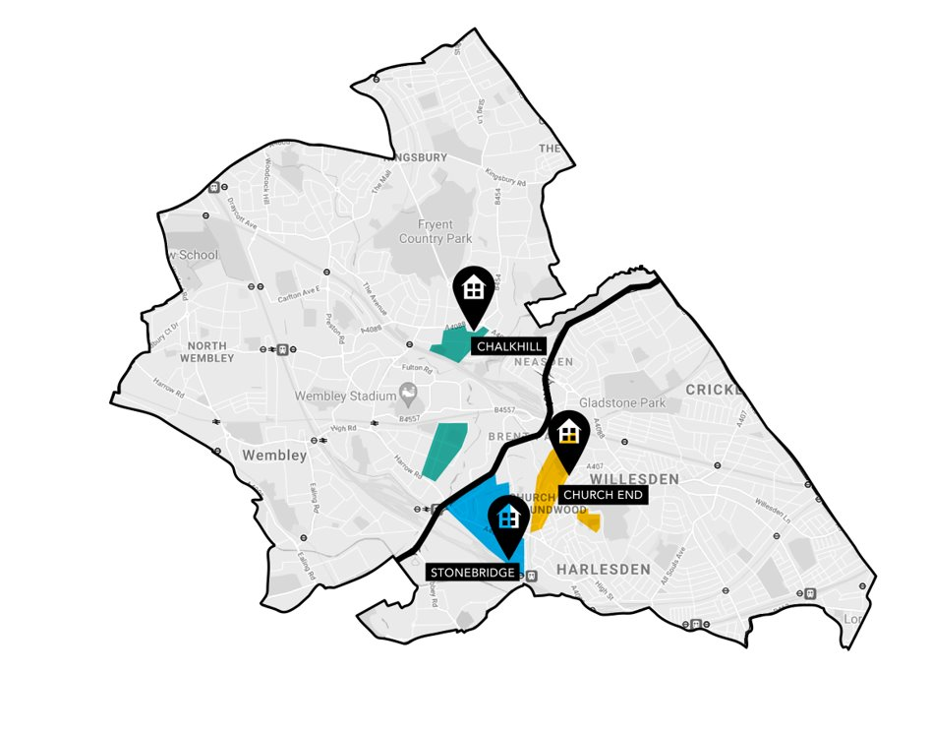

Role description
One Flow One Brent’s current Project Board is made up of 6 members, each bringing their own experiences, insights, and expertise to bear at the heart of our decision-making process. We are clear that in order to achieve our mission, young people must be meaningfully engaged in and able to influence decisions for One Flow One Brent.

We are excited to be recruiting 6 new young people to the Project Board, bringing with them fresh insight, energy and lived experience - so thank you for your interest so far!

Job title: One Flow One Brent Youth Board Member (6 roles, 2 for each estate)
Reporting to: One Flow One Brent Project Manager
Location: We expect Board meeting to rotate between Barham Park, MTVH office and some meetings to be virtual.
Time commitment: 5 hours a month
Salary: Paid at London Living Wage

What will the role consist of?
By joining the OFOB Project Board, you will:
- Bring your perspectives and lived experiences to the Board.
- Ensure the mission, purpose and values of the organisation are maintained.
- Act as an enthusiastic ambassador for OFOB to help raise its profile.
- Contribute to the overall direction and development of OFOB through your input, supporting our strategic planning and good governance.
- Build a positive relationship with the staff team that promotes honesty, transparency, and accountability. Support the development of the team, and assist with recruitment, where relevant.
- Attend monthly board meetings.
- Review funding applications and attend grant panel meetings as required
- Collaborate with One Flow Partners and Stakeholders

What support will I get?
We recognise that this might be the first time that you have ever sat on a Project Board of this type. We will put in place several steps to support you with the process throughout your membership, including (but not limited to):
- A full induction
- Training and support to ensure you feel equipped in carrying out the role.
- Mentoring and shadowing opportunities

Person specification
As well as being aged between 16 and 24 years old on 1st March 2023. As a young member of the Project Board, you will help support and deliver our commitment to ensuring the involvement of young people in our mission. This will include working with our Flourishing Futures Group, a group of 12 young people who advise across our employment strategy.

- Ability to work as part of a team whilst contributing an independent perspective.
- Ability to be an effective ambassador and influencer for One Flow One Brent
- Ability to devote the necessary time to the role.
- Understanding and acceptance of the role and responsibilities of Project Board Member.
- Commitment to taking youth voice and participation seriously.
- Sound judgement.

You'll also be:
- Passionate about supporting young people to prosper, no matter what their background is.
- Personable and have good communication skills.
- Willing to bring new ideas and perspective to our Board.
- A great listener, able to understand complex ideas.

Essential skills
- A commitment to the mission and purpose of One Flow One Brent
- A commitment to furthering social mobility.
- Working as part of a team
- Influencing others
- Relationship building

Things you don't need, but might help:
- Experience of being any one of the following: youth voice group, youth club, community group, school council, youth council, religious group/ club, or other committee/ panel
- Any other form of volunteering, advocacy, or ambassador work

What are the benefits?
- An opportunity to make a difference to the lives of other young people by supporting a cause you care about.
- Directly grow your professional network by working with, and learning from fellow Board Members, the wider Young Brent Foundation team, the sector, and other inspiring young people just like you.
- Help your career journey by enhancing your CV and work experience, by developing skills such as strategic thinking, business planning, giving feedback and leadership.
- Gain confidence within and insights into the youth sector.

How to apply

For any questions or quires about the youth board, the roles or accessibility requirements please reach out to Jean Marc Okende - jm.okende@youngbrentfoundation.org.uk or Zorka Keszthelyi - Zorka.keszthelyi@youngbrentfoundation.org.uk

Please complete the application form using the following link. Apply Here

Deadline for applications:26th May 2023

