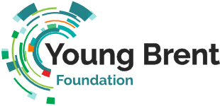
Network Meeting
Agenda
6th October 2021
11:00am – 12:30pm
Time | Detail | Lead by
11:00 – 11:05 | Welcome & Introduction | Chris Murray
11:05 – 11:10 | Introduce training with an overview of areas identified | Beverley Anim-Antwi
11:10 – 11:25 | Breakout room discussions – Training areas | Members
11.25 – 11.35 | Feedback from members | Beverley Anim-Antwi
11.35 – 11.45 | CVS Brent - training opportunities available | CVS Brent
11:45 – 12.00 | WNST training and Natural History Museum/BGW Training | Sport at the Heart (Nary and Matt)
12noon – 12.10 | Comfort Break
12.10 – 12.25 | Aspire Training project update | Maxine Willets
12.25 – 12.30 | Close | Chris Murray

Theme – Training
Topic: YBF Network Meeting
Time: 6th October 2021 (11:00am – 12.30pm)
Join Zoom Meeting
Topic: Young Brent Foundation - Network Meeting
Time: Oct 6, 2021 11:00am London
Join Zoom Meeting: Insert link
Meeting ID:
Passcode:

