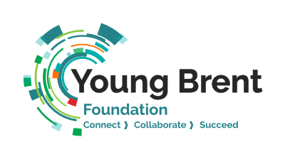
Elevate Fund (Project Grants) - Application Form
Application timeline:
- Applications are received on a rolling basis all year round.
- Panel will meet and make decisions monthly.
- The grant is accessible to all members for a maximum of £5000 per opportunity. Larger grants may be considered subject to supporting evidence and justification.

Title of the project:
Project Start and End Dates:

Section A: Personal and Organisation Details
Name of Organisation
Name of Lead Contact and Position
Alternative Contact Email
Address
Email
Phone
Legal Status i.e., Charity, CIC, CIO etc
Charity Number (if applicable)
Website
Social Media

What does your organisation do? (100 Words)

What is its primary Focus? (50 Words)

Section B: Eligibility check
Is your organisation a member of YBF? | Yes/ No
Has your organisation received funding directly from John Lyon’s Charity before? | Yes/ No
Has your organisation received the same grant within the past 12 months? If so, which one? | Yes/ No
What is the income of your organisation in the latest financial year? Please supply financial proof.
Does your organisation have a Safeguarding and Child Protection Policy? Please attach it in the application. | Yes/ No

Section C: The activity/project
In summary what is the main purpose of your funding request (50 words)
“The funding is for…”

Why is this activity/project needed in your community? How will children and young people benefit from it? (200 Words)

How have you involved parents/young people in the decision making and planning for this activity/project?

How do you intend to work in partnership with other voluntary sector partners to deliver improved outcomes for children and young people?

Section D: Budget
How will you spend the grant? Please provide a detailed budget (Please attach).

Will you be seeking additional source of funding to support the activity/ project?

Section E: Project evaluation
Who will be the beneficiaries?
Age Group: | Number of beneficiaries:
What will be the outputs?
Activities:  (E.g. vocational workshops) | Number of sessions:  (E.g. 5 sessions)

What are the indicators you will use to measure the changes of participants in terms of their behaviour, attitude, condition and knowledge?
How else will you monitor and evaluate the project?
Behaviour:
Attitude:
Condition (Optional):
Knowledge:
Others:

Once completed, please return the form and attachments to grants@youngbrentfoundation.org.uk. If you have any difficulties completing or submitting this form, please email the address above.

