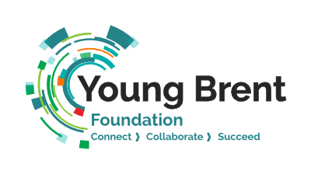
Elevate Fund (Main Grants) - Application Form
Application timeline:
- Applications are received on a rolling basis all year round.
- Panel will meet and make decisions monthly.
- The grant is accessible to all members for a maximum of £5000 per opportunity. Larger grants may be considered subject to strong supporting evidence and justification.

Title of the project:
Project Start and End Dates:

Section A: Personal and Organisation Details
Name of Organisation
Name of Lead Contact and Position
Alternative Contact Email
Address
Email
Phone
Legal Status i.e., Charity, CIC, CIO etc
Charity Number (if applicable)
Website
Social Media

Section B: Eligibility check
Are you’re a member of YBF? | Yes/ No
Have you received funding directly from John Lyon’s Charity before? | Yes/ No
Have you received the same grant within the past 12 months? If so, which one? | Yes/ No
What is the income of your organisation in the latest financial year? Please provide financial proof.
Do you have a Safeguarding and Child Protection Policy? Please attach it in the application. | Yes/ No

Section C: Use of grant
What does your organisation do? (100 Words)

What is its primary focus? (50 Words)

Why is the grant needed? How will the organisation benefit from it? In turn, how is it going to benefit children and young people in Brent?

Please provide an example/ case study on one of your past programmes. Please detail the activities, duration, number of participants and outcomes.

Who will be the beneficiaries?
Age Group: | Number of beneficiaries:

How do you intend to work in partnership with other voluntary sector partners to build your organisation’s capacity?

Section D: Budget
How do you plan to spend the grant? Please provide a budget (Please attach).

Section E: Evaluation
Do you agree to provide a report on the following 12 months after receiving the grant, should the application be successful?
- An overview of the operation
- Types of activities and number of sessions organised
- Number of beneficiaries and their profile
- Staff changes and development (if any)
- What the grant has enabled the organisation to achieve
What are other areas you will look at?
Yes/ No
Other areas:

Once completed, please return the form and attachments to grants@youngbrentfoundation.org.uk. If you have any difficulties completing or submitting this form, please email the address above.

